PYTHON AUTOMATION SCRIPT
Internship Task 1 :
1. Title
Python Automation Script for File Organization and Renaming
2. Objective
The objective of this project is to automate file management operations using Python.
The script organizes files into different folders based on file type, renames files automatically, generates logs for operations performed, and handles errors using exception handling.
3. Problem Statement
Managing files manually can be time-consuming and inefficient.
This automation script helps organize files automatically by sorting them into folders such as Text, Images, and PDF.
The script also keeps track of all operations in a log file.
4. Features Implemented
- File sorting automation
- Automatic file renaming
- File movement operations
- User input support
- Logging system
- Exception handling
- OS module usage

5. Project Structure
Task1_Automation/
── automation.py
── logs.txt
└── test_folder/
── Text/
── Images/
── PDF/
6.Folder Before
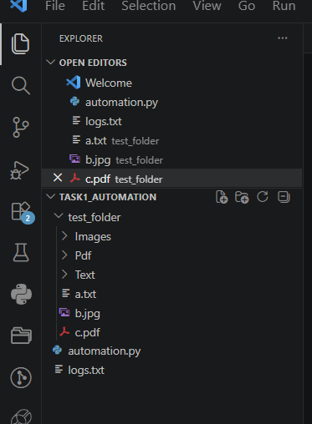

7.code
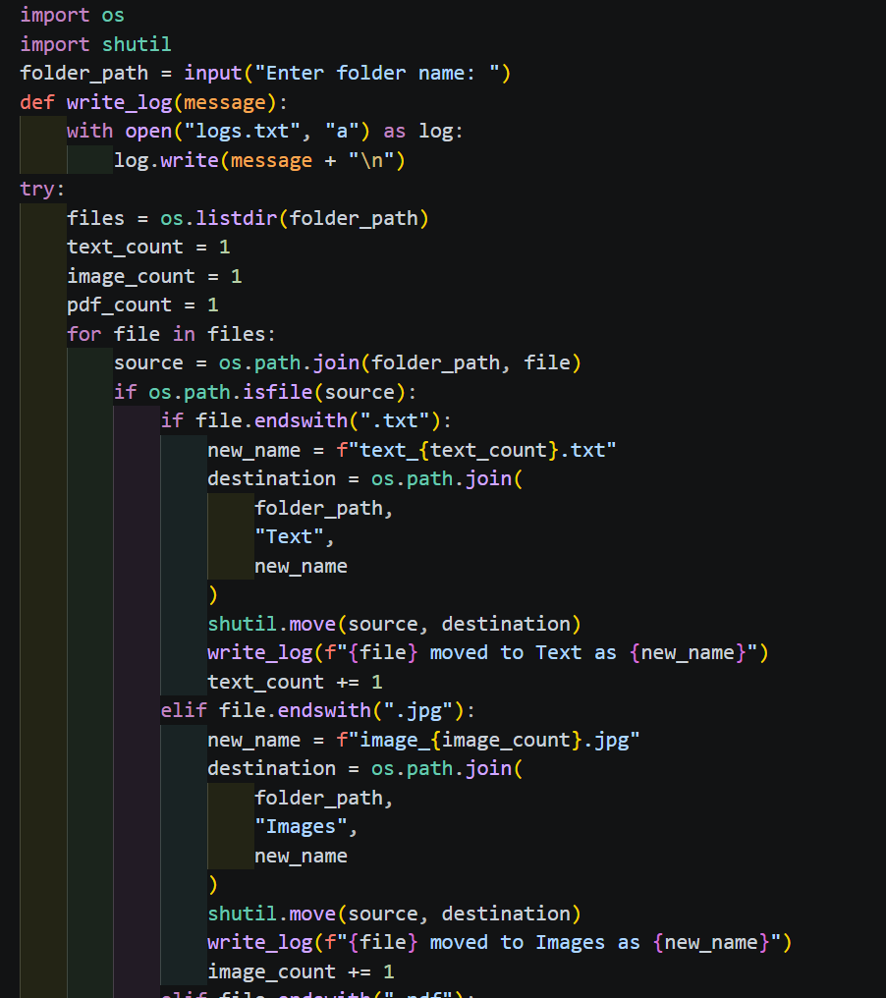
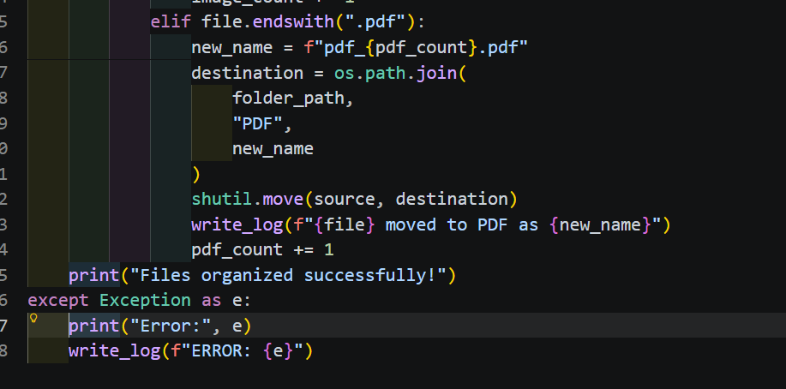
8.Terminal Output
9.Folder after
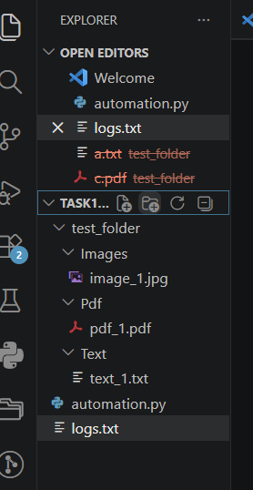
10.Log file
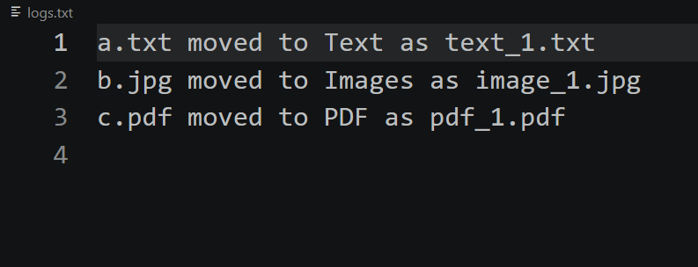

11. Explanation of the Code
Importing Modules
- os module is used for file and folder operations.
- shutil module is used for moving files.
User Input
The program asks the user to enter the folder name.
Logging
A log file named logs.txt is created to store all operations performed by the script.
File Sorting
The script checks file extensions:
- .txt → Text folder
- .jpg → Images folder
- .pdf → PDF folder
File Renaming
Files are renamed automatically using counters:
- text_1.txt
- image_1.jpg
- pdf_1.pdf
Exception Handling
try-except is used to prevent program crashes and handle errors safely.

12.Conclusion
This project successfully demonstrates Python automation using file handling, renaming, sorting, logging, and exception handling.
The automation script improves file management efficiency and reduces manual effort.’
13. Future Enhancements
- Support more file types
- GUI interface using Tkinter
- Automatic scheduled execution
- Duplicate file detection
- Cloud storage integration

